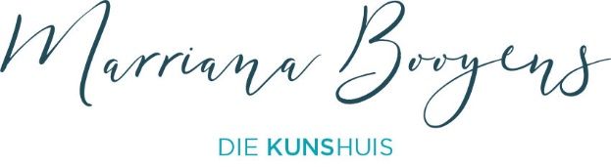

**Art Studio Fees and Options 2025**

**Adult Classes**

* All classes (except Online classes) are 2.5 hours long / 10 hours of class per month .
* Classes are scheduled once per week, **except in *School holidays*** or on ***Public holidays***. Online classes are 2 hours.
* The more classes you book, the lower the rate per class. Class fees include Tea and Rooibos tea. If you like Filter coffee, then please bring some along.
* The ***Flexi Option*** is an exception, and can be scheduled over 5 months.

Students provide their own art materials, some can be bought from my Art Studio directly. As soon as a payment confirmation is received, the **List of materials** will be provided.

**Options available for enrolment as a student:**

***Option A***

***7 months Contract 24 classes booked Weekly classes***

***Payment per month*** */* ***upfront*** *for* ***each month****.*

**Normal rate:** R1300 per month for 7 months (R 379,16 per class).

**Student rate:** R 1250 per month for 7 months (R 364.58 per class).

**School children /Young adults (20 years and younger ):** R 1250 per month for 7 months (R 364.58 per class).

**Pensioners (65 and older):** R1250 per month for 7 months (R 364.58 per class).

***Option B:***

***3 months Contract 12 classes booked Weekly classes***

***Payment upfront***

**Normal rate:** R 4560 / R 380 per class.

**Student rate:** R 4380 / R 365 per class.

**School children/ Young adults (20 years and younger)**: R 4380 / R 365 per class

**Pensioners rate:** R 4380 / R 365 per class

**Option C: Flexi Option**

***Payment upfront / Min of 2 classes scheduled per month.***

***1 class booked at R 450 per class***

***2 - 6 classes booked at R400 per class***

***7 - 11 Classes booked at R 390 per class***

***12 or more classes booked at R 380 per class.***

***No discount offered on the Flexi Options***

*The benefit of* ***Option C*** *is that you have more flexibility in booking your classes, as the classes doesn’t have to be every per week, but you have to* ***do at******least 2 per month.*** *You could also do more.*

*Any Flexi Option classes booked must be finished* ***within a 5 month timeframe****. Time span starts from the first class booked.*

*Communication is key for this option, as you will have to arrange a time slot with me via email, or on* ***Telegram.*** *I will check available space as soon as you reguest to book a class, and arrange a class slot with you.*

***Pre requisites for Option C:***

* *At least 2 classes booked by the student per month.*
* *Please remember that once you have booked a class, and then cancel the class, it will still count as a class. I can try to* ***shift the class*** *to* ***another group in the same week****, but if that is not possible, the class will be forfeited.*

*If you want to experience the classes before you commit to more classes,* ***Booking only one class*** *is possible.*

***Cost is R 450 for one In Studio class (2.5 hours), and R 400 for one Online class (2 hours).***

**Children’s Classes (aged 5 to 13)**

***The children’s classes are once per week, except in school holidays or Public Holidays.***

**Booked per term.**

R 250 per class (1. 5 hours), ***payable upfront for the term***. Includes some art materials.

Please email me if you have any other questions.

[marrianabooyens@gmail.com](mailto:marrianabooyens@gmail.com)

